# <h4> The Insider Bar </h4>

The insider bar contains various useful tools that are invaluable to a tester, providing many shortcuts and cheats that allow the tester to quickly create or destroy ships, modules, items and NPCs, amoungst various other features. To have access to the insider bar the account you are using must have various GM roles applied to it, these are normally applied as standard but if the insider bar is not visible, first check that it not simply toggled off, by right clicking on the Neocom bar and selecting ‚ `toggle insider‘. If this option is not available then it is likely that the account you are using does not have the necesary roles, and you should contact your team lead or second to get the roles asigned. </p>

## <h4>Slash Commands </h4>

Slash commands are what testers of EVE online use in order to speed up the entire process of testing. They allow a tester to travel over systems instantaneously, create ships, items, in game money (ISK), have super characters etc that would otherwise take a long time to acquire. </p>

There are so many slash commands that this list could turn into at least 5 pages of documentation so the following slash commands are the basics to introduce a new tester to the world of EVE online. </p>

<img src=“slash.jpg” /> </p>

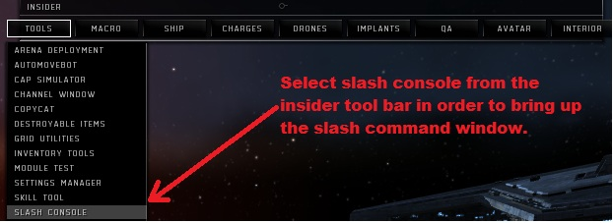

*note – Brackets are not needed. </p>

/tr me (enter system name) <b>**This allows the player to travel instantaneously to another location.** </b> </p>

*e.g.*  ***</b>/tr me Rens </br>***

***/tr “Charactor Name” Rens “REASON FOR TRANSFER”</b> </p>***

/credit concord me (amount) <b>**gives player in-game money (ISK) </b> </p>**

*e.g. <b>****/credit concord me 100000000 </br>***

***/credit concord “Charactor Name” 10000000 “REASON FOR TRANSFER”</b> </p>***

/create (“ship” or “item”) e.g. (“Maller” for ship or “foxfire rocket” (quantity) for items) <b> **Creating items will place them in the cargo hold of the current active ship. This can cause problems as it allows your cargo to be overloaded, which prevents a player from doing certain things. </b> </p>**

/load me (“ship” or “item”) -<b> **This will only allow an item within the active ship’s cargo capacity to be given. </b> </p>**

/spawn (ship) - <b>**Only used in space, which will spawn a ship right next to the player. </b> </p>**

/Heal me - <b>**Quick heal command. Heals hull, armor and shield to 100%. </b> </p>**

/super me -<b>**Maxes out the characters skill points allowing them to do/use anything in the game</b> </p>**

/noob me - <b>**Sets characters skill points to 0. </b> </p>**

/ hop (distance in meters) -<b> **Jumps the player in the direction they are moving by the value set.** **</b> </p>**

/online me - <b>**Activates all offline modules on a ship. </b> </p>**

/crimewatch clearall me -<b> **Clears all criminal flags on the player</b> </p>**

/nuke – <b>**kills all enemies within player radius. </b> </p>**

/fit me (“item”) - <b>**Fits the user specified item to the players ship. </b> </p>**

**For more slash commands click on the following link: <a href="**<https://partnerwiki.ccpgames.com/externalqa/eve/wiki/Slash_Commands.html>**"><u> EVE Wiki Slash Commands </u></a> </p>**

*tip : pressing up on the arrow keys after clicking on the command line will repeat the last slash command that you entered into the command window. </p>

## <h4>Copycat </h4>

Copycat is a useful tool for spawning fully fitted ships instantaneously. When using a slash commands to spawn or load a ship, the player only ever receives a blank ship hull without any modules fitted and as such getting a fully fitted ship can be time consuming. </p>

<img src="copycat_insider.jpg" /> </p>

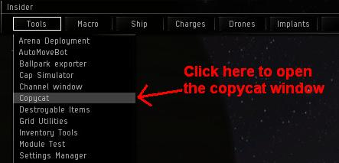

When the copycat window opens it should look something like this: </p>

<img src="copycat.jpg" /> </p>

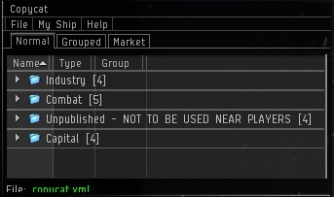

Displayed is a list of subfolders containing various fully fitted ships provided by CCP that can be used for various different purposes, from combat ships used for combat missions or PvP to industrial ships used for mining and the hauling of large amounts of materials. </p>

### <h4> Adding other ships to copycat </h4>

For the purposes of some scripts or just due to personal preference, it may sometimes be necessary to add ships to copycat, so that they can easily by accessed at anytime or to save time fitting ships for scripts. To facilitate this, copycat uses unique keycodes for each ship that contain all the information on the ship and its fitting, these are called <b>**DNA Keys</b>.** To add a ship using its DNA key firstly copy it to your computers dashboard. Then in the copycat window select File->Import->DNA from clipboard. </p>

<img src="copycat_import.jpg" /> </p>

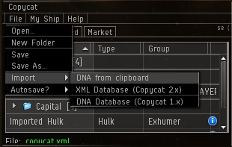

A window appears which allows you to give the fitted ship a unique name. Once named, the ship will appear in the copycat window as standard. </p>Websites

(You should bookmark them all in your browser)

<http://esil.ccpgames.com/> - **Server info for EVE online.**

<https://bugs.eveonline.com> – **Defect tracker used to submit any found defects.**

<http://uk-image/> - **For entering how many hours you have worked. To be done before 10.00am every Friday.**

<https://partnerwiki.ccpgames.com/externalqa/eve/wiki/Category_ExternalQA.html> - **Vast index knowledgebase for EVE testing. Very useful**

<http://qawiki/index.php/Main_Page> - **e4e Wiki - Wiki contains all of the documentation, procedures, “how to” and training material.**